Project Design Phase-II
Data Flow Diagram & User Stories
Date | 04 October 2026
Team ID | SWTID-2026-6870
Project Name | Streamlining IT Procurement: Automating Standard Laptop Orders with Flow Designer
Maximum Marks | 4 Marks

Data Flow Diagrams
A Data Flow Diagram (DFD) shows how data enters and leaves the system, what changes it, and where it is stored. The diagram below shows the flow for a Standard Laptop order.
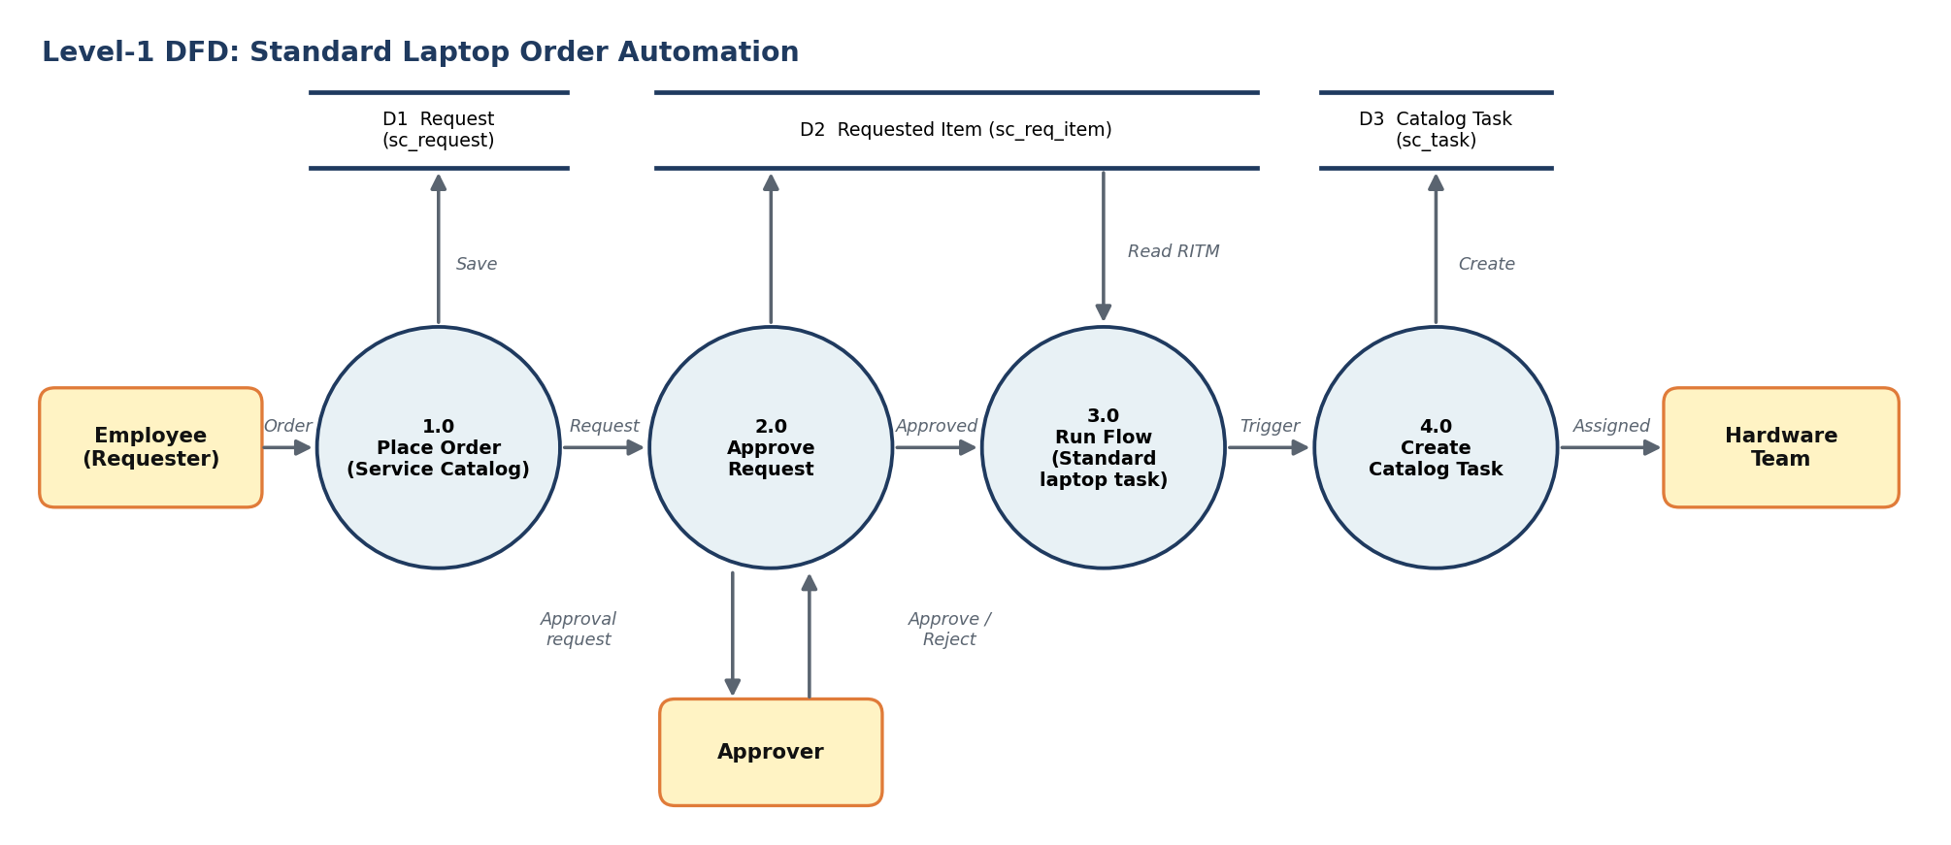
Figure 1: Level-1 Data Flow Diagram
Element | Description
Employee (Requester) | Places the Standard Laptop order from the Service Catalog
1.0 Place Order | Creates the Request (REQ) and Requested Item (RITM) records
2.0 Approve Request | Approver reviews and approves the request in the Approvers related list
3.0 Run Flow | Flow "Standard laptop task" starts through the Service Catalog trigger and reads the Requested Item
4.0 Create Catalog Task | Create Catalog Task action creates a task in sc_task with short description, description, assignment group Hardware and approval Approved
Hardware Team | Receives the task and configures the laptop

User Stories
User Type | Functional Requirement (Epic) | User Story No. | User Story / Task | Acceptance criteria | Priority | Release
Flow developer | Flow creation | USN-1 | As a flow developer, I can create the flow "Standard laptop task" in the Global application running as System User. | Flow appears in Flow Designer list | High | Sprint-1
 |  | USN-2 | As a flow developer, I can add the Service Catalog trigger so the flow starts when a catalog item is ordered. | Trigger saved with Service Catalog | High | Sprint-1
 |  | USN-3 | As a flow developer, I can add the Create Catalog Task action with short description, description, Assignment group Hardware and Approval Approved. | Action shows all field values | High | Sprint-1
 |  | USN-4 | As a flow developer, I can save and activate the flow. | Flow status is Active | High | Sprint-1
Catalog administrator | Flow assignment | USN-5 | As a catalog administrator, I can attach the flow to the Standard Laptop item under Process Engine. | Process Engine shows the flow name | High | Sprint-1
Employee | Ordering | USN-6 | As an employee, I can order a Standard Laptop from Service Catalog > Hardware by clicking Order Now. | Order status page shows request number | High | Sprint-2
Approver | Approval | USN-7 | As an approver, I can approve the request from the Approvers related list. | Approval state becomes Approved | High | Sprint-2
Hardware team member | Task verification | USN-8 | As a Hardware team member, I can see a catalog task assigned to my group with a clear short description. | Task visible under the Requested Item | High | Sprint-2
Project team | Testing | USN-9 | As the project team, we can run functional tests and UAT on the flow. | All test cases executed and recorded | Medium | Sprint-2
 | Documentation | USN-10 | As the project team, we can document the project and results. | Report completed | Medium | Sprint-2

